Idea: Improvement in software and Hardware interface for CNC Machines

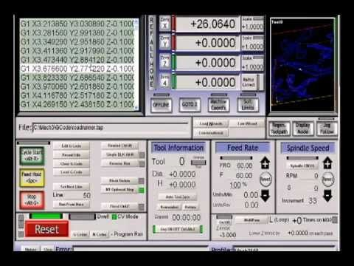

**Problems:**

* Too many options and too many buttons
* Difficult to learn and master for beginners.
* Lack of cross-platform options
* Security issues for user response when using a mouse.
* Lack of emergency buttons
* Lack of options for tactile interaction
* Not tablet or mobile device options
* Easy/Hardware interface?
* Jogging options

Intended Population:

* UF engineering Students working on capstone projects or manufacturing
* DIYers
* Makers-CNC owners

**The solutions:**

* A renew Interface for PC
* Addressing security options
* Including Mobile / tablet options
* Including a Hardware interface
* Wifi access

**Interview and Testing:**

* There is a lot of user forums for the CNC community online where we can get feedback from
* Testing software would not be difficult. Hardware would be something else.

HCI Principles:

* Speed
* Cognitive - to learn a process
* Safety
* Other? I don’t know right now

**Some links to software:**

* [Top 14 Open source GRBL Projects](https://awesomeopensource.com/projects/grbl)
* Chillippr webspace <http://chilipeppr.com/> (JSON and javascript)
  + <https://github.com/chilipeppr/serial-port-json-server>
* <https://github.com/grbl/grbl> (C )
* Promising interface, private, not open (<https://ultimatecnc.softgon.net/en/screenshots>)